

**APIWIZ - Frontend SDE - I / SDE - II / SDE - III Role Assignment**

**Title:** JSON Tree Visualizer

**Objective:** Build an interactive JSON Tree Visualizer web application that allows users to visualize JSON data as a hierarchical tree structure with search and highlighting functionality.

**Functional Requirements:**

1. **JSON Input & Parsing (Mandatory):**
   * Create a text area where users can paste or type JSON data
   * Validate JSON input and show error messages for invalid JSON
   * Provide a "Visualize" or "Generate Tree" button.
   * Include a sample JSON as placeholder.(optional)
2. **Tree Visualization using React Flow (Mandatory):**
   * Use React Flow library to create the tree visualization, **don't use any other library**
   * Display JSON structure as a hierarchical node tree with:
     1. **Object nodes**: Show object keys
     2. **Array nodes**: Show array indices
     3. **Primitive nodes**: Show key and value (string, number, boolean, null)
   * Connect parent-child nodes with lines.
   * Use different colors for different node types:
     1. Objects (blue/purple/ any color as per your choice)
     2. Arrays (green any color as per your choice)
     3. Primitives (orange/yellow/ any color as per your choice)
3. **Search Functionality (Mandatory):**
   * Implement a search bar that allows users to search by **JSON path** (e.g., $.user.address.city, items[0].name)
   * When a search is performed:
     1. Highlight the matching node with a distinct color.
     2. Pan the view to center the matched node
   * If no matches found, Show "Match found" or "No match found" message
4. **Basic Interactive Features: (Optional)**
   * **Zoom controls**: Zoom In/Out/Fit View buttons
   * **Pan**: Allow dragging the canvas to navigate
   * Display node information on hover (path and value)

**Technical Expectations:**

* HTML, CSS (you can use Tailwind or SCSS), and JavaScript or any modern frontend framework like React,Angular, Vue, Next.
* Clean and modular code structure.
* React Flow for tree visualization.
* **Do not use any AI tools ****.**

**Deliverables:**

1. Fully functional web application (hosted on GitHub Pages, Netlify, Vercel or similar)
2. GitHub repository link with clean commits and README.

**Bonus (Optional but Impressive):**

* Dark/Light mode toggle.
* Clear/Reset button to clear input and tree.
* Copy JSON path: Click a node to copy its path
* Download tree as image

**Evaluation Criteria:**

* UI/UX design and responsiveness
* Code quality, readability, and maintainability
* Creativity in JSON visualization
* Implementation of optional features will earn bonus points

**Design reference:**

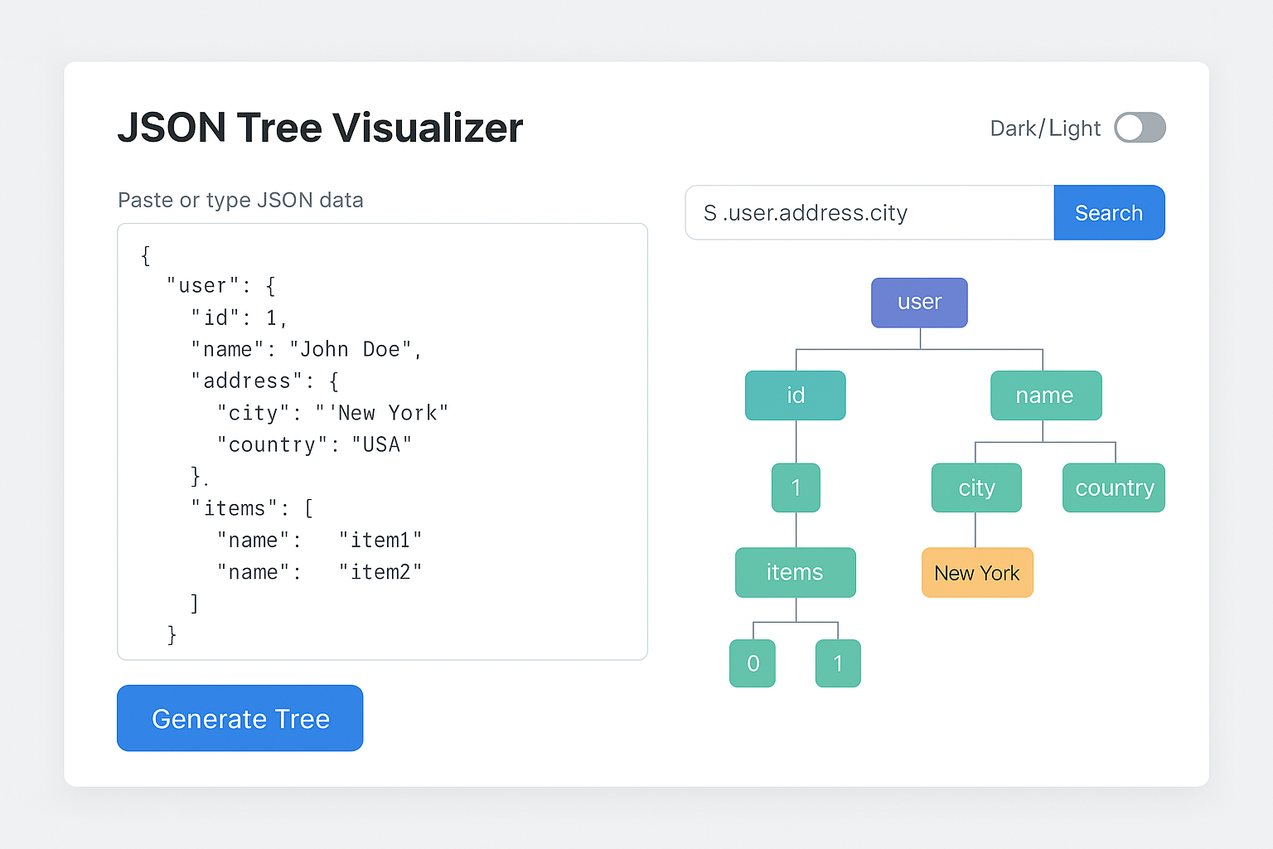

**NOTE:** The provided UI is for reference only. There's no Figma or fixed design — you're free to interpret and improve the UI/UX based on your understanding of the project’s goals. We’re open to your creative direction.

**Submission Deadline:** 30th Oct, 2025 - 10:00 PM

**Submission Link:** [Google Form](https://forms.gle/rAcGEPdnQvCKiv4a7)

**Good luck!**